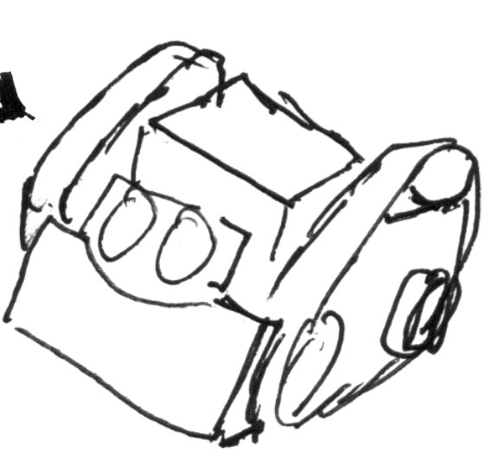

Sumo Robot League

Online Resources

## [3D Files of Robot Parts](https://drive.google.com/open?id=0B4flp9EZKozra2ZvdVFlTk5ON3c) http://bit.ly/2rQwSgI

## [GitHub, TextBook code](https://github.com/SumoRobotLeague/MRK-2)

## [Youtube Channel](https://www.youtube.com/channel/UC0WCv8s-wjs_T7GnELdtvow) <http://bit.ly/2rz3hZL>

Accessible pins

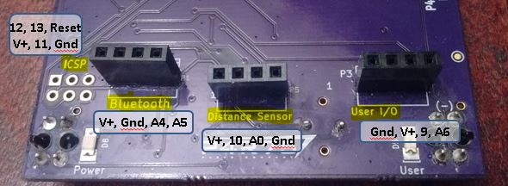

Table of all pin assignments

